Task
I Look at the artist Ed Fairburn’s website and find out some interesting facts about him.
Write down a few facts that you have researched and learned about Ed Fairburn.
I have created 2 Double pages with different papers
- Glued down different papers – newspapers, magazines etc
- Cut out and stuck down2 or more images from a magazine or newspaper that I like.
- I have use map paper both in colour and black and white.
I have drawn two observational drawing from the artist sheet.
I have used a fine liner to add tone and show good mark making skills
Challenge – I have made another two collaged pages with the map paper and other types of paper and drawn a face or an object from around my house in the style of the artist
Over the coming session you will be working in your small sketchbooks creating pages and making creative entries. You will be practicing and learning different skill and techniques, some techniques you have previous knowledge of, HOWEVER you will be using this knowledge and doing the task independently. This is great practice and you get to be as creative as you want. The finished journal will be a part of you GCSE and moderated so please take time and extra care when doing it. Below are images of sketchbook journals of collage pages to help you give and idea of what your final page may look like.

Task 1 - Ed Fairburn
If you can follow the link and then read about Ed Fairburn to find out about his artwork. If not follow the information sheet, - https://edfairburn.com/

Task 2 – Write some facts that you have found out about the
Ed Fairburn.
________________________________________________________________________________________________________________________________________________________________________________________________________________________________________________________________________________________________________________________________________________________________________________________________________________

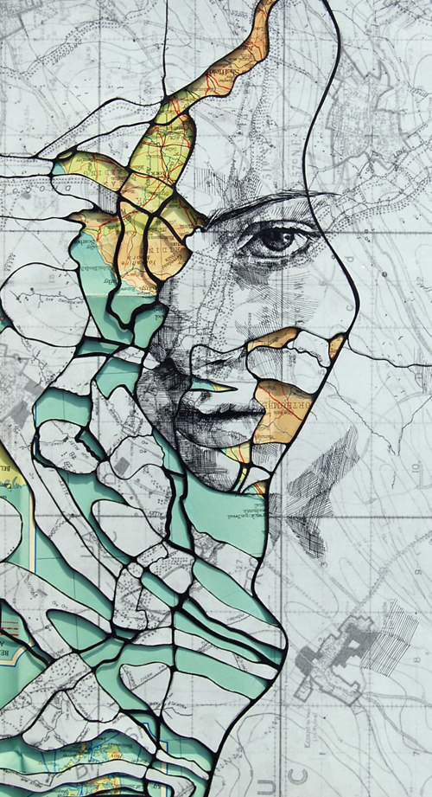

Task 3 - Collage your page as normal and take your photocopied piece of paper that have a map printed on it in black and white as well as colour. Rip the map paper into pieces and then stick the map paper onto your page. Once this is done a dry you will be ready to carry on with the next task

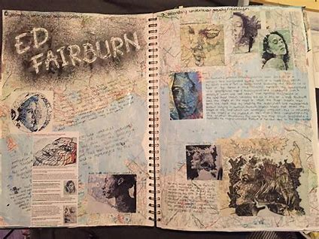

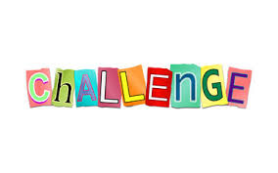
This week’s challenge!!!!
Find 2 or 3 different objects around your house and create another double page collage. Draw these images in the same style of Ed Fairburn.
What would look even better!! How about get an image of a family member, grandparent, parent, aunt, uncle, brother, sister or even a friend and draw their face on the map paper.
The extra challenge is to help you practice more techniques and will help you achieve and gain more marks!
Task 4 – Map Drawing
On the artist information sheet, you need to choose two images to work from of the artist images you have.
- Using a pencil first draw a section of the artist work for example, mouth, eye or nose.
- Use the tracing paper if necessary
- After drawing out the section you have chose on the map, go over your drawing in fine liner and add tone and shade to it where needed. Using different methods, you have learnt like cross hatching etc.

