[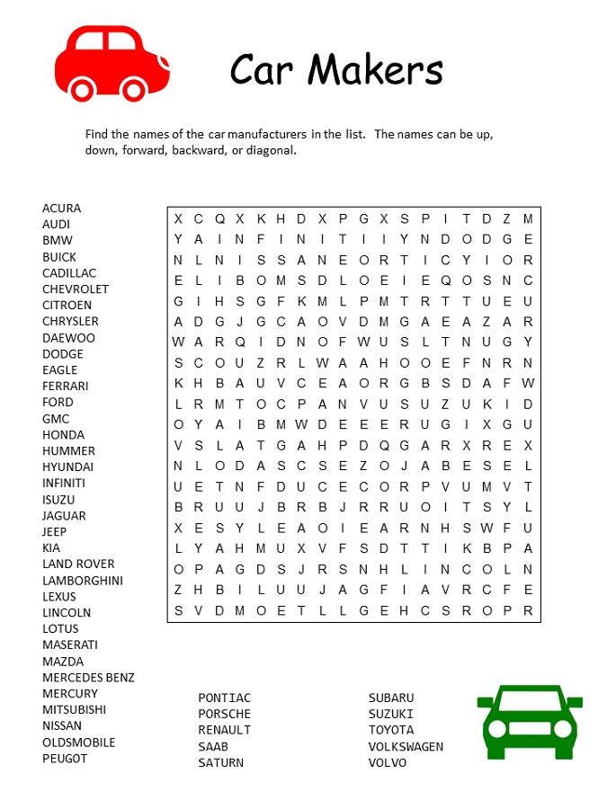](https://www.google.co.uk/url?sa=i&rct=j&q=&esrc=s&source=images&cd=&cad=rja&uact=8&ved=2ahUKEwivn8-M_5vnAhUpAWMBHTApDHAQjRx6BAgBEAQ&url=https://www.activityshelter.com/car-word-search-free/&psig=AOvVaw2uUT3xPx0xxqBvGqg33T62&ust=1579946898585074)