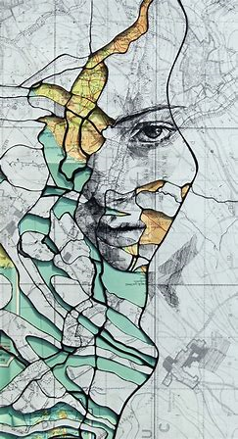
Ed Fairburn
“Paper maps are essential to portrait artist Ed Fairburn, who uses them as the canvas for his detailed work. His thoughtful integration of human portrait and topography make it appear as though the two have always belonged together” (Rocky Mountain PBS)

Born 15th November 1989 in Southampton, UK. Graduated from Cardiff School of Art and Design in 2012.
I manipulate paper maps to construct other forms, usually portraiture. I call this process top pointillism, a direct combination of topography and pointillism.

Using traditional materials such as ink, paint and pencil, I make gradual changes to the contours, roads and other patterns found in cartography. These changes allow me to tease out the human form, resulting in a comfortable coexistence of figure and landscape. I aim to preserve the functionality of each map by feeding the composition instead of fighting it – I often spend hours studying the terrain before I begin any physical processes. I am interested in the degree of subtlety behind each synchronisation, and the way in which a completed map behaves more like a portrait when viewed from further away – it’s almost paradoxical that a portrait should lose detail when examined closely.

