How to stay calm at home during social distancing – for pupils and parents
- Watch the news to stay informed however do not become consumed by it- do this by watching it at certain times and then switch it off.

- Watch some of your favorite films, programs or Netflix series. Is there something you can watch together and have a family film day or night?

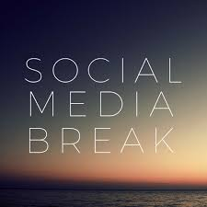
- Stay connected with family and friends via phone; video call or social media however have a break from your phone just like the news.

- Bake or make some nice food together. Maybe you can teach the people you live with what you have been learning in your cooking classes.

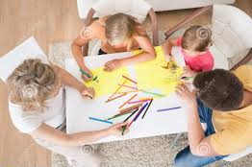
- Get creative together either by drawing, painting or making something

- Go for a social distance walk in your local area or get outside in nature if you have a garden to sit and play in.

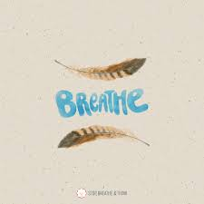
- Have space away from each other in your bedrooms- if you feel like it, do some mindfulness breathing. There are lots of YouTube clips at the end of this pack to choose from.

- Write, journal or doodle your thoughts and feelings down

- Listen to your favorite piece of music and have a dance. Make a social distancing play list together.

- Read your favorite book or a book you haven’t got round to reading

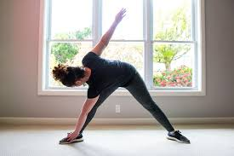
- Do some exercise at home- again there will be lots of clips on you tube

- Take some time to rest

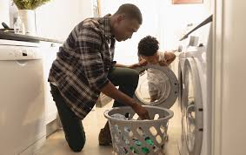
- Do that chore in the house that you have been meaning to do

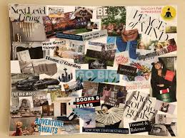
- Make a goal or vision board of the things you would like to achieve and do when things return to normal

- Remember this is temporary and things will resume soon.

Mindfulness You Tube Links
https://www.youtube.com/watch?v=bRkILioT_NA
https://www.youtube.com/watch?v=o8GrqUSdzi0
https://www.youtube.com/watch?v=Bk_qU7l-fcU
https://www.youtube.com/watch?v=9A0S54yAgEg
https://www.youtube.com/watch?v=sh79w9pn9Cg
https://www.youtube.com/watch?v=DWOHcGF1Tmc
https://www.youtube.com/watch?v=Q2UKw8tFYyY

Mindfulness Apps
https://www.smilingmind.com.au/

Breathr: Dr. Vo helped to develop this mindfulness app for youth with the Kelty Mental Health Resource Centre (British Columbia, Canada). Free for Apple and Android mobile devices!
Stop, Breathe, and Think: Web and mobile app for youth, with meditations for mindfulness and compassion.
Calm.com: Free website and mobile app with guided meditation and relaxation exercises.
Insight Timer: Free mobile app with virtual “bells” to time and support your meditations, and access to lots of guided meditations by many different meditation teachers (including Dr. Vo).
Plum Village: Zen Meditation. Free app for iOS, loaded with beautiful meditations and teachings in the Plum Village / Thich Nhat Hanh tradition.
MindShift: Free mobile app for teens developed by AnxietyBC, with mindfulness and other coping skills for anxiety.
Smiling Mind: Free mobile mindfulness app for young people, from Australia.
Headspace: “Meditation made simple.” This app has a free introductory period, after which it requires a paid subscription to continue to use.
Guided Meditation Recordings
In addition to mindfulnessforteen.com’s free guided meditations, here are a few more recordings:
Amy Saltzman, MD, Still Quiet Place: Mindfulness for Teens (CD)
Gina Biegel, LMFT, Mindfulness for Teens: Meditation Practices to Reduce Stress and Promote Well-Being (CD, MP3)
Larry Rosen, MD. “The Buddha and the Fig Tree.” (CD, MP3)
Mindful.org’s “Audio Resources for Guided Meditations” collection: Online, free guided meditations.

Take care,

Jamie-Leigh Agent

