Paper 2 – Viewpoints and Perspectives

This week we will learn more English skills focusing on ‘extreme situations’
We will work on:
AO1: Summarising information
AO4: Evaluation – expressing our own thoughts and feelings about a text.
AO1: Summarising similarities and differences between texts
AO2: Analysing a writer’s use of language

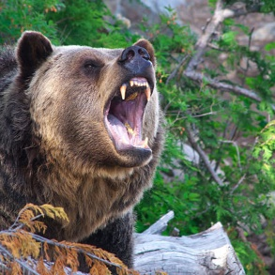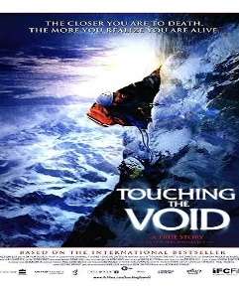

Extremes
I | I | W | Q | U | R | U | E | F | R | S | S | H | X | W | Z | W | T | C | Q
Y | J | B | V | Y | Q | F | R | C | D | O | J | V | X | J | G | B | R | T | X
G | G | P | I | K | F | E | G | K | U | P | A | D | Q | E | N | A | Y | F | T
V | Y | E | Z | Q | J | F | P | W | C | W | I | K | P | N | Z | S | B | A | B
X | P | H | X | Z | V | F | B | G | F | D | I | S | L | Y | Z | M | T | J | B
V | D | Y | Q | T | A | H | G | U | N | I | U | Z | G | R | L | B | E | W | C
Y | E | D | I | J | R | B | L | U | C | I | W | F | Y | E | J | V | P | D | H
A | C | N | F | L | S | E | O | X | H | H | Y | V | S | F | K | A | U | D | K
D | P | F | Q | N | N | C | M | A | X | Y | O | F | B | E | H | T | A | B | S
H | P | C | G | F | W | L | Y | E | R | D | D | C | I | P | J | N | S | I | U
H | K | M | C | R | G | Z | S | P | Y | S | V | A | F | R | K | I | R | E | O
O | P | L | Y | G | N | I | T | I | C | X | E | E | C | Q | R | Z | U | R | R
O | U | Q | Z | N | I | B | V | Q | X | L | Q | W | M | B | J | O | D | N | E
Y | Z | E | K | N | Z | N | D | D | V | K | U | Q | P | U | N | O | H | A | G
V | K | T | C | T | A | O | R | Q | A | W | X | I | X | N | A | O | I | E | N
Q | J | O | D | P | M | W | I | I | Z | U | R | N | Q | U | B | V | P | W | A
E | P | H | W | D | A | M | E | K | S | H | E | J | V | S | F | O | L | R | D
Z | A | I | T | Z | W | T | W | E | A | K | V | B | T | U | H | N | H | P | F
X | X | I | L | S | B | G | O | F | P | O | Y | K | P | A | X | X | R | A | F
F | V | D | M | X | Q | Z | X | F | M | W | C | X | R | L | V | Q | M | M | N

EXTREME
WEIRD
DANGEROUS
AMAZING
UNUSUAL
AWFUL
EXCITING
CRAZY
MAD
HORRIFYING
RISKY

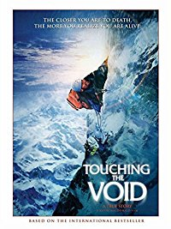

Read this text then answer the questions on the next page.
Hiker forced to eat beloved pet dog that saved his life
Alsatian chased away bear that ransacked camp leaving man stranded without food in Canadian wilderness
A hiker who was stranded in the Canadian wilderness for nearly three months after a bear destroyed his supplies was forced to eat his beloved dog. Marco Lavoie escaped with his life when his German Shepherd chased away the wild animal that attacked their camp - destroying their canoe and food supplies - just days into a planned three-month climbing trip. But three days later, the 44-year-old killed his heroic Alsatian with a rock and ate it in a desperate bid to survive.
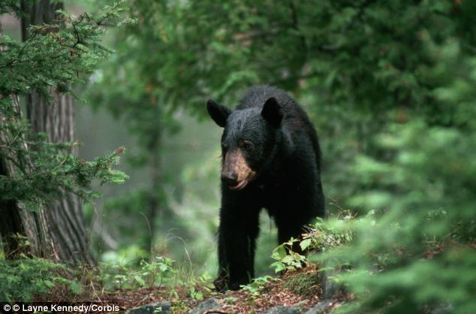
With no way to call for help, the stranded explorer then spent a further three months alone and starving before a search party came to the rescue. By the time Mr Lavoie was airlifted out of the Nottaway River wilderness, about 800km from Montreal, he had lost half his body weight, was suffering from hypothermia and was unable to speak.

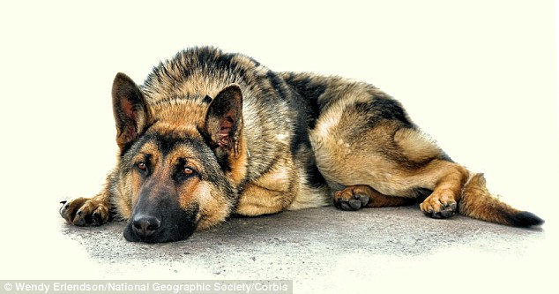

Surprisingly, Expert, Caleb Musgrave, a survival instructor, said eating the dog was a natural instinct of the human body as a result of extreme hunger: 'When you start to go hungry, your mind breaks.' He added: 'Up there, there's little plant life to live off, so he would have been slowly, painfully dying when they found him. If he had not eaten the dog he would have died. It was a good decision'
Mr Lavoie's family only reported him missing in the past few weeks after he failed to return from the planned solo trip to Lake Matagame. Several survival experts agreed that conditions in the Nottaway River wilderness were tough, with temperatures dropping below freezing.
Mr Lavoie is currently in serious condition in hospital.

Learning Objectives: AO1 and AO4 | Red | Amber | Green
- Know how to summarise information
- Use evaluation skills and support your opinions with relevant information.

- Using bullet points, make a list of the most important information in this article.

- Write a paragraph explaining what you would have done in this situation.
_____________________________________________________________________________________________________________________________________________________________________________________________________________________________________________________________________________________________________________________________________________________________________________________________________________________
Read this extract from ‘Touching the Void’
Watch this clip https://www.youtube.com/watch?v=pqmYP0OmHcw
Touching the Void
In this text a man has to make a decision whether to kill his friend in order to survive.
High in the mountains, a blizzard raging around them, Joe Simpson and Simon Yates were fighting for their lives. Simpson had shattered his right leg in a fall near the 21,000-foot summit of the Mountain, leaving Simon Yates, then 21, with the impossible task of getting himself and his crippled climbing partner off the mountain alive.
For nine hours he had been lowering Simpson 300 feet at a time. Then, just as they had some hope, Simpson began slipping faster and faster. He tried to stop himself, but he couldn’t. He kicked his left boot into the snow, but the loose powder would not hold. Suddenly, Simpson swung out into space. The rope jerked hard, and he found himself spinning in the air, over a massive hole that was hundreds of feet deep.
100 feet above, Yates felt the nylon rope suddenly pull tight and knew Simpson had gone over a vertical drop. He listened for Simpson’s voice through the howling winds. Frostbitten and exhausted, Yates waited helplessly for an hour, knowing that any movement might send them both tumbling to their deaths. Suddenly, the snowseat Yates had dug into the mountain began to give. He reached for the Swiss Army knife in the pocket of his backpack. “There was no other option left to me,” he later told Simpson. “The rope exploded at the touch of the blade, and I flew backwards into the seat. I was shaking.”
Certain he had sent his friend plunging to his death, Yates continued down the mountain and finally made it to base camp six miles away.
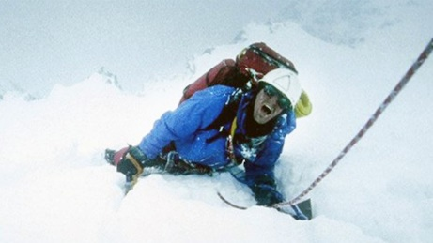

On the next page you will be asked to look for similarities and differences between this text and the article about Marco Lavoie eating his dog.

Learning Objectives: AO1 | Red | Amber | Green
- To be able to summarise similarities and differences in two texts.

- Similarities between the texts
- Summarise the differences between the texts
Touching the Void | Connective | Marco Lavoie
Simpson and Yates were climbing in the Peruvian Andes | whereas | Marco Lavoie was climbing in the Canadian Wilderness
Simpson was in danger because he fell and broke his leg.

Yates survived because he…. |  | Marco survived because he….

Learning Objective: AO2 | Red | Amber | Green
- To analyse how a writer uses language to interest the reader.
Read through the text on the next page and identify the language techniques and what this quote suggests about their situation.
Quote | Language technique/Word type | This suggests…..
“howling winds that had hit them”

“He strained for the sound of Simpson’s voice”

‘Frostbitten and exhausted’

“The taut rope exploded at the touch of the blade”

Verbs
Adverbs
Adjectives
Alliteration
Personification

Learning Objective: AO2 | Red | Amber | Green
- To analyse how a writer uses language to interest the reader.
Some 100 feet above, Yates felt the nylon rope suddenly yank taut and knew Simpson had gone over a vertical drop. He strained for the sound of Simpson’s voice through the howling winds that had hit them shortly after completing the first-ever ascent of Siula Grande’s West Face the previous afternoon. Frostbitten and exhausted, Yates waited helplessly for an hour, knowing that any movement might send them both tumbling to their deaths. Suddenly, the snowseat Yates had dug into the mountain began to give. Instinctively, he reached for the Swiss Army knife in the pocket of his backpack. “There was no other option left to me,” he later told Simpson. “The taut rope exploded at the touch of the blade, and I flew backwards into the seat as the pulling strain vanished. I was shaking.”
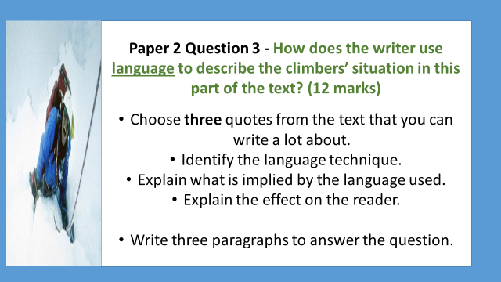
Follow this structure x 3
The writer uses………………..in the line “…………….” to describe……………….The verb/adjective/adverb “…….” makes the reader feel that………………..
Furthermore……..
____________________________________________________________________________________________________________________________________________________________________________________________________________________________________________________________________________________________________________________________________________________________________________________________________________________________________________________________________________________________________________________________________________________________________________________________________________________________________________________________________________________________________________________________________________________________________________
____________________________________________________________________________________________________________________________________________________________________________________________________________________________________________________________________________________________________________________________________________________________________________________________________________________________________________________________________________________________________________________________________________________________________________________________________________________________________________________________________________________________________________________________________________________________________________

AO2: Analysing language and the effect on the reader.
How does the writer use language to describe the climbers’ situation in this part of the text?

Have you chosen relevant quotes?
Have you identified the correct language techniques?
Have you commented on the effect on the reader?
Have you used correct spelling? If not, give the correct spellings.
Have you used correct punctuation?
WWW:

EBI:

Learning Objectives: AO5 and AO6 | Red | Amber | Green
- To show understanding of how perspectives can change in a diary entry for a blog.
- To write effectively and imaginatively.

Imagine you are engaging in an extreme activity like the ‘Ice Mile’ or the mountain climbing in ‘Touching the Void. ‘
Use your understanding of how perspectives can change in a text to write a diary entry for an Extreme Sports Blog.
Day 1 (before the extreme activity)
Explain what you will be doing tomorrow

Describe how you feel about it

Day 2 (the day of the activity)
Describe the extreme activity – are there any difficulties?

How does it make you feel?

Day 3 (the day after the activity)

How do you feel about the activity today?

What would you do differently next time?

__________________________________________________________________________________________________________________________________________________________________________________________________________________________________________________________________________________________________________________________________________________________________________________________________________________________________________________________
____________________________________________________________________________________________________________________________________________________________________________________________________________________________________________________________________________________________________________________________________________________________________________________________________________________________________________________________________________________________________________________________________________________________________________________________________________________________________________________________________________________________________________________________________________________________________________
__________________________________________________________________________________________________________________________________________________________________________________________________________________________________________________________________________________________________________________

