Planning menus for different age groups
In these lessons you will learn
First Lesson
- How nutrition changes as we get older or out lifestyle changes.
- Know what nutrition a young child needs (2-5 years)
- Know what nutrition a child needs (5-12 years)
- Know what nutrition a teenager needs.
Second lesson
- Know what nutrition an adult needs.
- Know what nutrition an elderly adult needs.
- Know what nutrition a pregnant women needs.
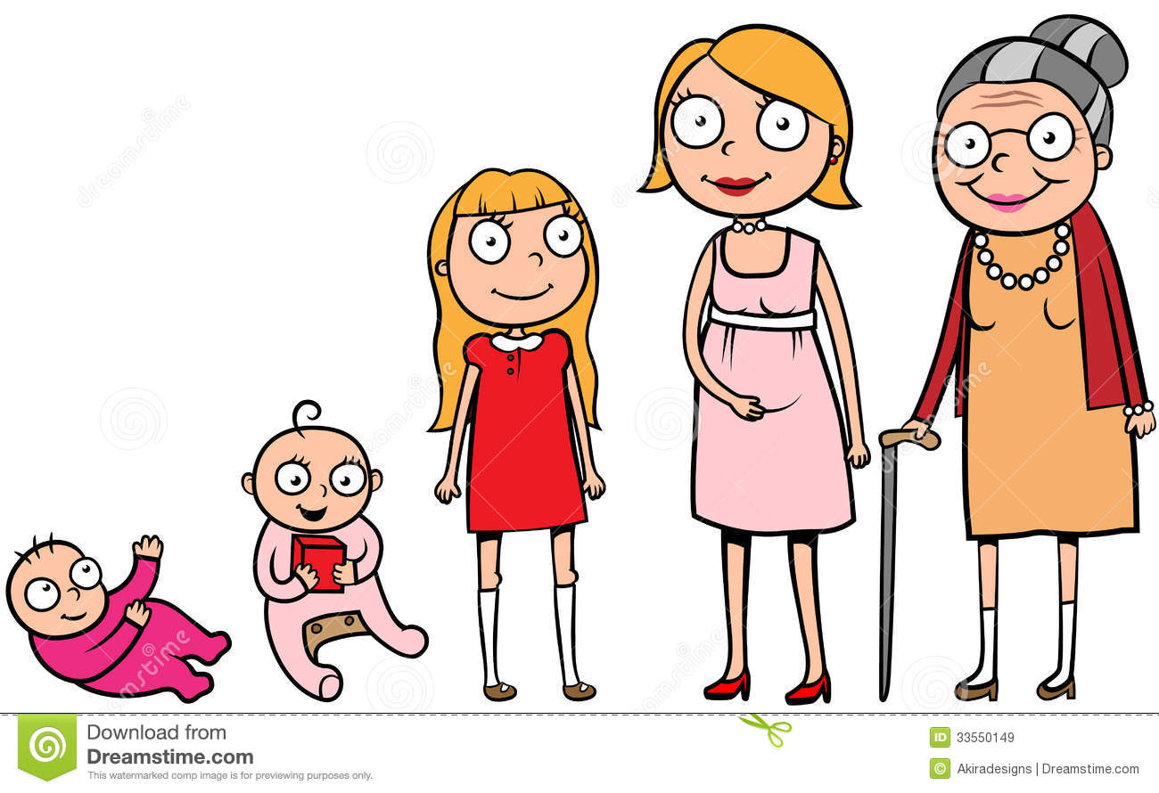
This Photo by Unknown Author is licensed under CC BY-NC

Task 1
Watch the bitesize video with this link
https://www.bbc.co.uk/bitesize/guides/z7yttv4/video
Task 2
Have a go at the kahoot quiz on the video make sure you put your name so I can see your answers.
https://create.kahoot.it/share/age-and-diet/e45bb1a0-34ca-4ee8-86d7-30af25de9588

2-5 year olds
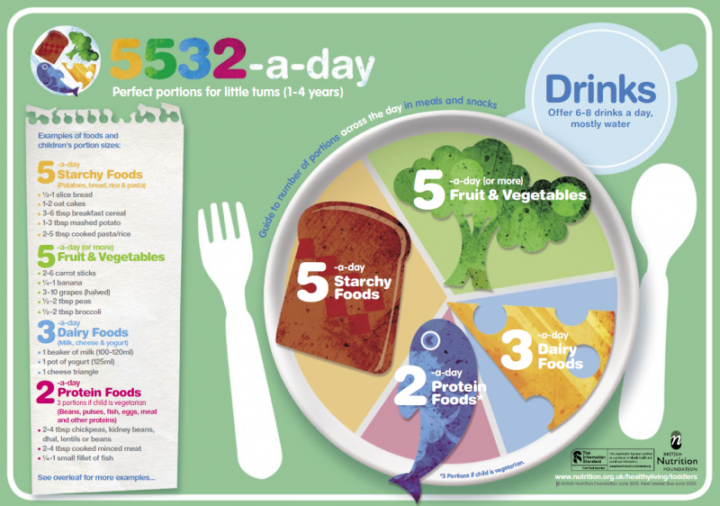
- Young children have small stomachs so need small but frequent meals to get the energy they need.
- 300ml Milk or a substitute a day gives all the Calcium they need for strong bones and also is a good source of Vitamin A.
- Good healthy eating habits should be encouraged with young children to help them develop good eating habits.
5-12
- Need lots of energy because of their activity
Nutrient | Reason | Examples
Protein | To help them grow and repair the body. | Fish fingers, boiled eggs
Carbohydrates | Starchy carbohydrates and some fat provides energy. | Pasta, Rice
Fat |  | Nuts , Dairy
Calcium | For healthy teeth and bone development | Milk, Cheese
Vitamin D |  | Tuna,Salmon
- Young children should avoid to much salt, saturated fats and sugars as these can effect their health.
Teenagers
- Should have a balanced diet!
- Are Rapidly growing so need lots of protein and calcium.
- Teenagers need to following nutrients.
Nutrient | Reasons | Example foods
Protein | To cope with growth spurts. Boys tend to need more protein than girls when their muscular tissue develops | Omelette  Roast Chicken
Iron | Teenage girls lose Iron when they have their periods so need to replace it or they could become anaemic | Spinach  Beef
Vitamin C | Is needed to absorb Iron | Peppers  Strawberries
Calcium | The skeleton grows rapidly at this time so this is needed to help bones grow and be strong | Milk Yogurt Kale Tofu
Vitamin D |  | Tuna Salmon Mackerel

Use the information to answer the multiple choice questions and the longer GCSE exam questions.

Task 3 Multiple Choice questions
- Why do teenager need lots of protein?
- For growing bones
- For growing muscle
- They need more energy
- For good eyesight

- Why do teenage girls need more Iron?
- They are bigger
- They start puberty earlier
- Their brains are bigger
- Because they have periods

- Which vitamin helps absorb Calcium for strong bones?
- Vitamin A
- Vitamin B12
- Vitamin C
- Vitamin D

- Which vitamin helps absorb Iron to make red blood cells?
- Vitamin A
- Vitamin B12
- Vitamin C
- Vitamin D

- Children are very active so need lots of energy where should the get most of their energy from?
- Sugar
- Starchy Carbohydrates
- Protein
- Fat

- Which group needs more protein in their diets?
- Teenage boys
- Teenage girls
- Young children
- Babies

- Which of these foods are good sources of Protein?
- Cheese, Milk and Kale
- Rice, Bread and Pasta
- Carrots, Peppers and oranges
- Tofu, Fish and meat

- What is vitamin D found in?
- Milk
- Fish
- Rice
- Spinach

Task 4 Answer the Past GCSE question on young peoples nutrition
Why do young children need Calcium and what can they get it from? (3 marks) _______________________________________________________________________________________________________________________________________________________________________________________________________________________________________________________________

2) Jenny is 15 and has been told by the doctor she is anaemic, explain why she might be anaemic and what she should have in her diet to help. (4 marks)
________________________________________________________________________________________________________________________________________________________________________________________________________________________________________________________________________________________________________________________________________________________________________________________________________________________

3) School need to plan healthy lunches for their children suggest 3 appropriate dishes and why they are suitable an example is shown below. (12 Marks)
Explanation about protein 1 mark
1 mark for sensible choices
Example: Baked Fish cake, with carrots and peas and mashed potato. The fish is a good source of protein needed for growth. The carrots and peas have Vitamin C in and are 2 of your 5 a day. Mashed is a starchy carbohydrate for energy and has milk added for extra Calcium.
Explanation about Carbohydrates 1 mark
Explanation about Vitamin C 1 mark

_________________________________________________________________________________________________________________________________________________________________________________________________________________________________________________________________________________________________________________________________________________________________________________________________________________________________________________________________________________________________________________________________________________________________________________________________________________________________________________________________________________________________________________________________________________________________________________________________________________________________________________________________________________________________________________________________________________________________________________________________________

