Task | Instructions/guidance
Starter Activity  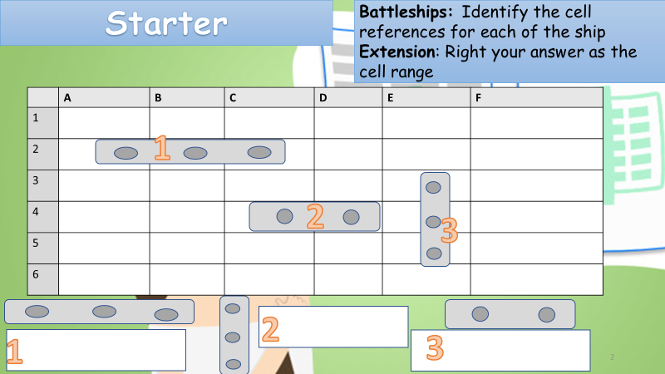 | You may use your help guide from last lesson to help with this  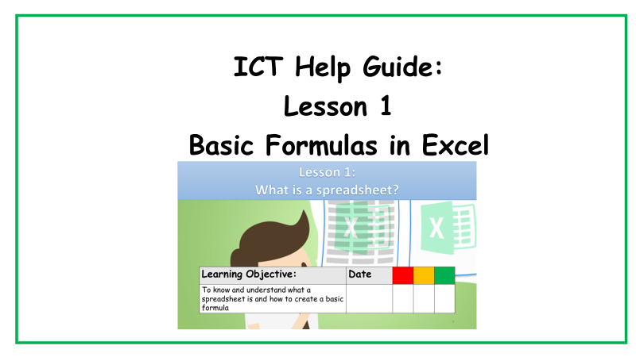
Task 1: Match the function with the definition  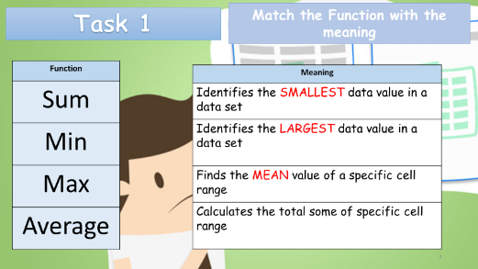 | 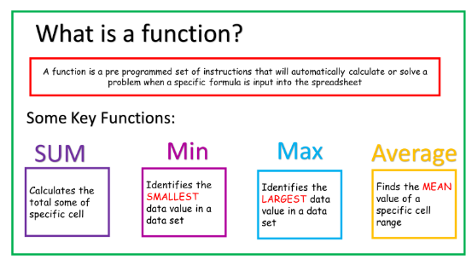  use page 2 in the help guide if you need support with this
Task 2: Using the help guide complete the spreadsheet inserting Sum, Min, Max and average functions  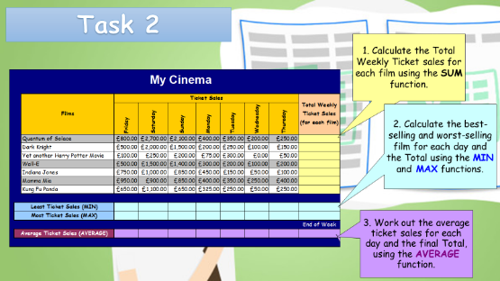 | Use the step by step guide for each function to help you complete this task  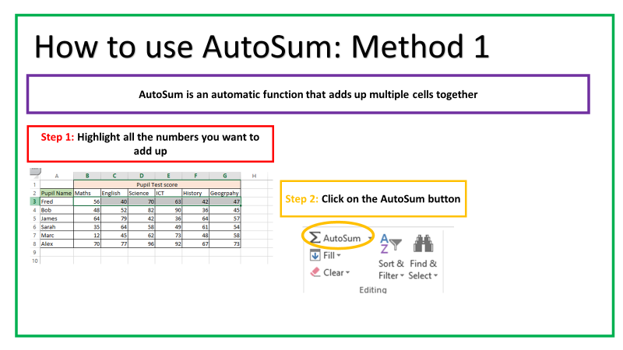  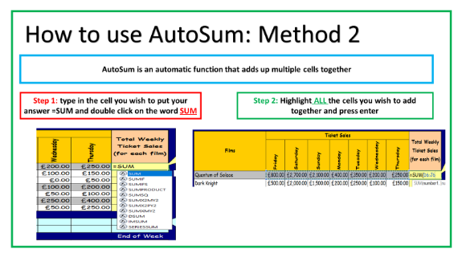  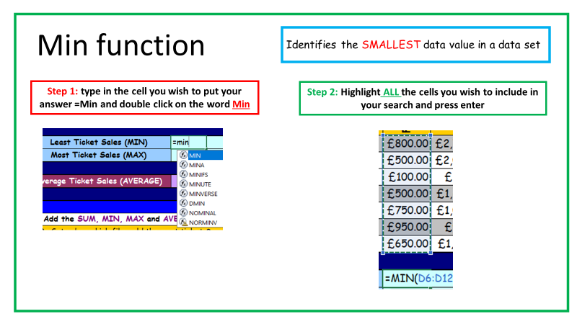  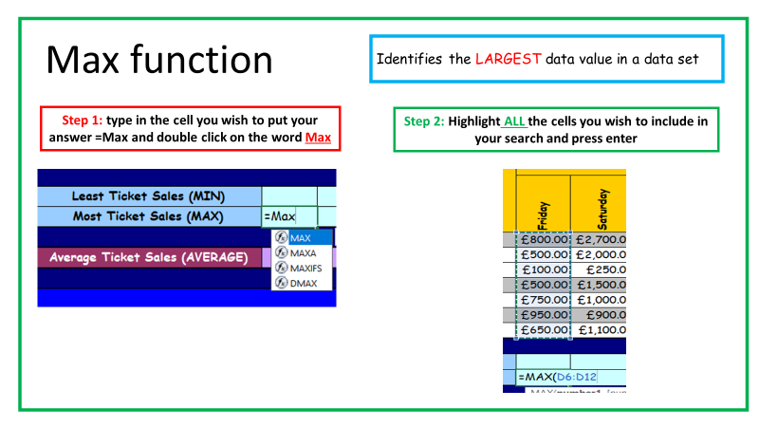  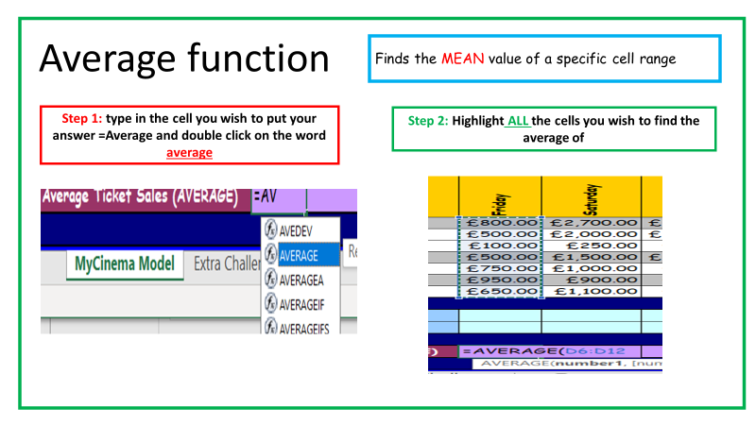
Extension task: using the information in the spreadsheet answer the questions

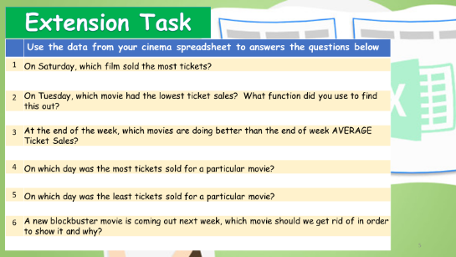
Self evaluation: tick the box you think you are  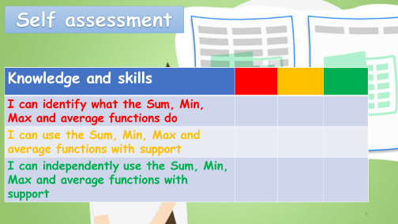 | Red = I struggled with this  Amber = need a little more help with this  Green = I understand this
Save files as the pupil’s initials and lesson 2 e.g. JM lesson 2

